1. Create repository on github
2. Create new angular project
   1. >ng new ecom
3. Open project in vs code
4. Add bootstrap and bootstrap navbar into that project
5. Run project by
   1. >ng s –o
6. Working with github
7. Publishing project on github pages
   1. >ng add angular-cli-ghpages
   2. 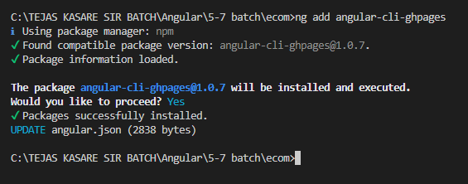
   3. Push code on github
      1. >git init
      2. >git remote add origin https://github.com/tejaskasare14/ecom.git
      3. >git add .
      4. >git commit –m “first commit”
      5. >git push -u origin main
   4. Go to github and refresh
   5. Setting up github pages
      1. On github -> go to setting -> pages ->
         1. Source -> deploy from branch
         2. branch -> main -> save
8. build angular application
   1. ng build --base-href "https://tejaskasare14.github.io/ecom/"
   2. 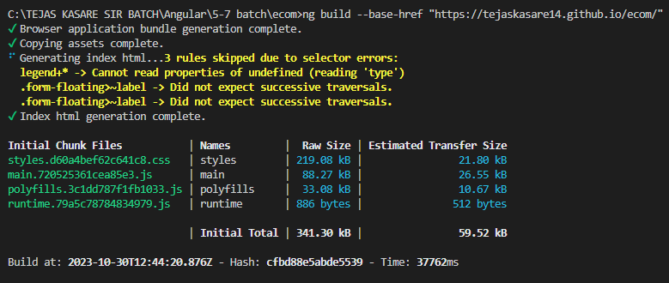
9. Deploy angular application
   1. >npx angular-cli-ghpages --dir=dist/ecom
   2. 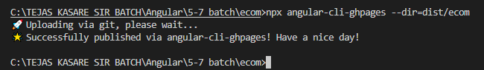
10. Change branch in github setting
    1. 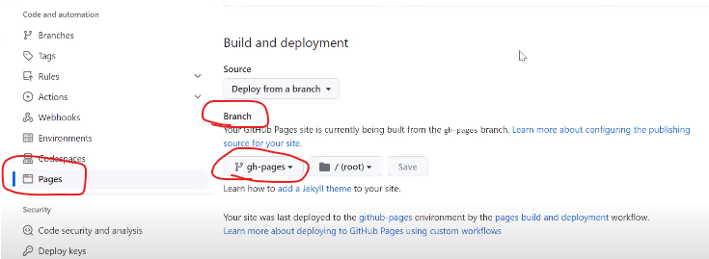
11. DONE
12. After making changes in project
    1. >git add .
    2. >git commit –m “your message”
    3. >git push -u origin main
    4. ng build --base-href <https://tejaskasare14.github.io/ecom/>
    5. npx angular-cli-ghpages --dir=dist/ecom
13. DONE!!!!!!!!!!!